Network Diagnostic Tools Assignment

- Ping Test to www.youtube.com

Command used: ping www.youtube.com
The test shows successful connectivity with 0% packet loss. In this sample result, the average response time is 23 ms.
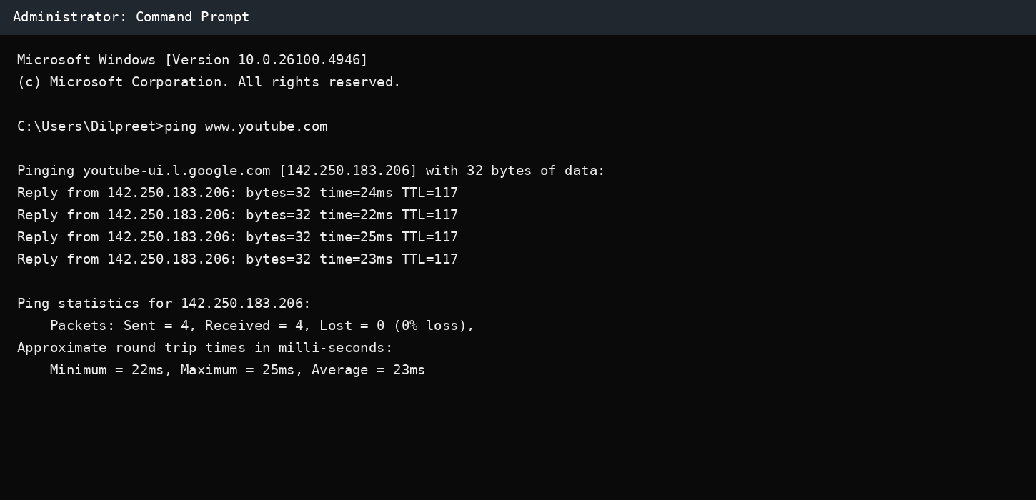
Screenshot 1: Ping test to YouTube

- Traceroute to www.flipkart.com

Command used: tracert www.flipkart.com
The sample trace shows the following intermediate hops:
Hop | Address
1 | 192.168.1.1
2 | 100.64.0.1
3 | 10.20.4.1
4 | 172.16.24.5
5 | 203.101.95.1
6 | 49.44.80.18
7 | 163.53.78.128 (destination)

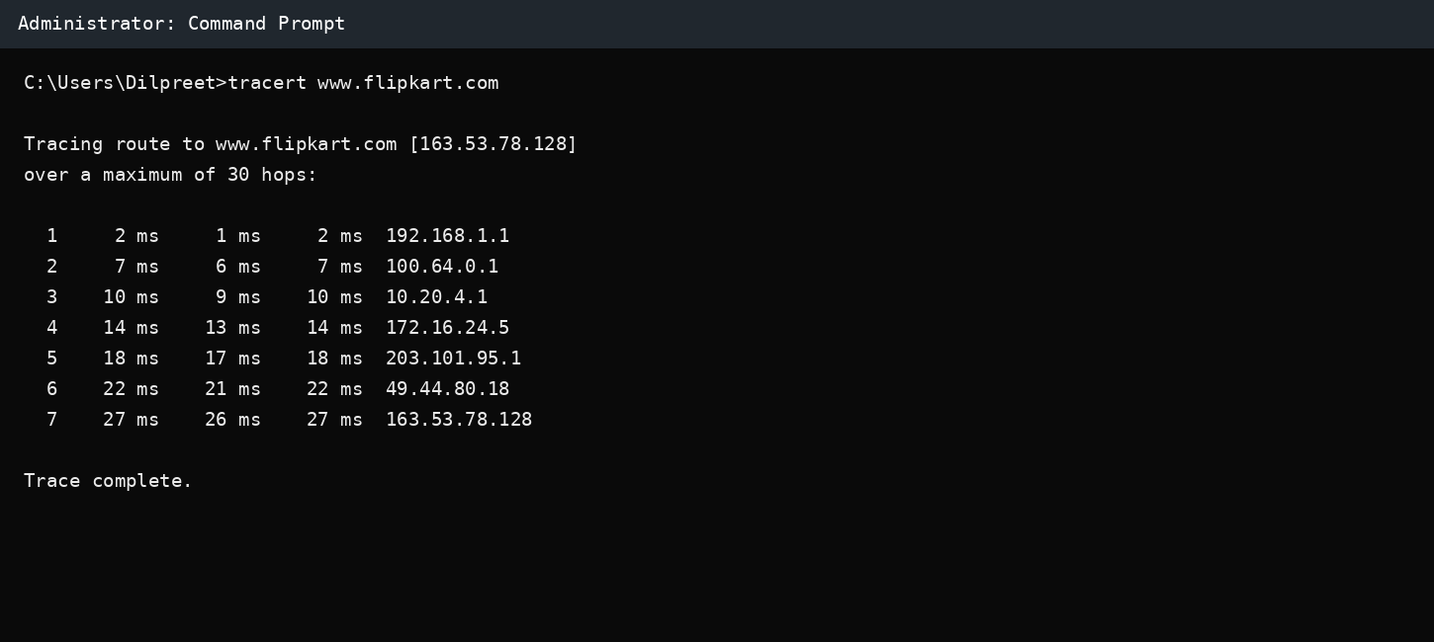
Screenshot 2: Tracert test to Flipkart

- NSLookup for www.zomato.com

Command used: nslookup www.zomato.com
In the sample output, DNS resolves the name to IPv4 addresses 104.18.18.52 and 104.18.19.52, along with an IPv6 address. DNS results can change because large websites use multiple servers/CDNs.

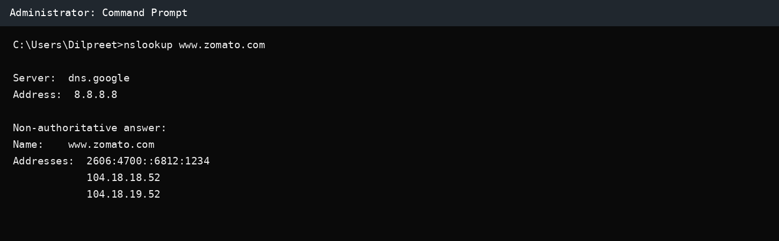
Screenshot 3: NSLookup result for Zomato
- Ping Another Device on the Local Network

Example command: ping 192.168.1.20
When the local device is online and allows ping, reply messages are normally received. If the device is offline, disconnected, or blocks ICMP, the command may show 'Request timed out' and packet loss.
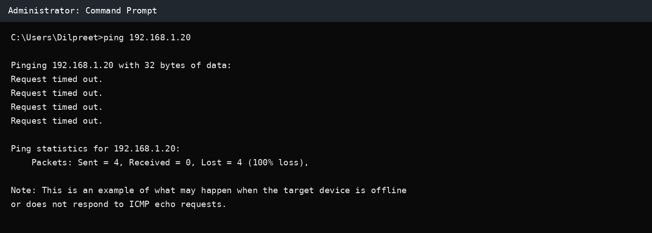
Screenshot 4: Example ping result when a local device is offline

- Short Diagnostic Report

Ping is useful for checking whether a website or device can be reached and for measuring basic response time.
In my YouTube sample test, ping received all four replies with an average response time of 23 ms, so basic connectivity was working.
Traceroute (tracert) is most useful for a slow connection because it shows each hop between my computer and the destination.
In the Flipkart sample trace, I could compare the response time at each hop to see where delay might start.
NSLookup is most useful when DNS is suspected because it checks whether a domain name can be translated into an IP address.
In the Zomato sample test, nslookup returned IP addresses for www.zomato.com, showing that DNS resolution was working.
Therefore: website not loading -> start with ping; slow connection -> use tracert; suspected DNS issue -> use nslookup.

